MODULE – 2
SESSION- 1
Q.1 Write a short paragraph in your own words defining what a 'program' is and give one real-life example from any app you use daily (like Instagram, Zomato, or Paytm).
OUTPUT-
A program is a set of instructions written in a programming language that tells a computer or mobile device what to do. Programs are used to perform specific tasks such as sending messages, ordering food, making payments or playing games.
Example1, in Zomato, a program allows users to select food, place an order, make payment, and track the delivery.
Example2, when I use Paytm to send money to someone, the Paytm program processes my details, verifies the transaction, transfers the money, and displays the payment status.

Q2. List three popular programming languages you have heard of, and for each, mention whether it is usually compiled, interpreted, or can be both.
OUTPUT-
Programming Language | Usually Compiled / Interpreted

Java | Compiled to bytecode, then executed by the JVM

Python | Interpreted

JavaScript | Interpreted/JIT compiled

Q3:- Flowchart for Booking a Movie Ticket on BookMyShow
OUTPUT:-
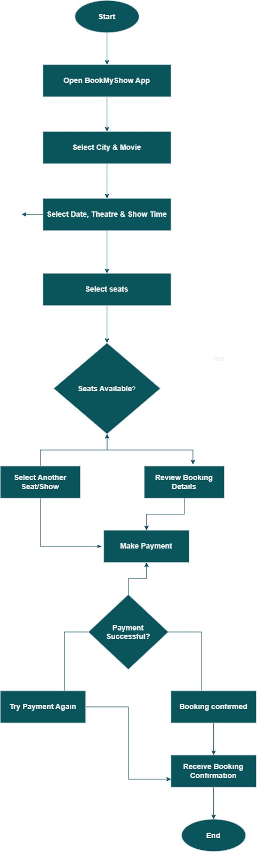

Q4.Write down the steps (as an algorithm, using simple numbered instructions) for ordering food on Swiggy — from opening the app to completing payment.
OUTPUT-
1 Start
2 Open the Swiggy app.
3 Log in or enter your mobile number.
4 Enter or select your delivery address.
5 Search for a restaurant or food item.
6 Select a restaurant.
7 Choose the required food items.
8 Add the items to the cart.
9 Check the order details and total amount.
10 Click on Proceed to Checkout.
11 Select a payment method.
12 Make the payment.
13 Wait for the payment confirmation.
14 The order is placed successfully.
15 Track the food delivery through the app.
16 End.

